Project Design Phase
Solution Architecture

Date | 30 September 2026
Team ID | SWTID-2026-4912
Project Name | AI WeatherWise
Maximum Marks | 4 Marks

Solution Architecture:
Solution architecture is a complex process – with many sub-processes – that bridges the gap between business problems and technology solutions. Its goals are to:
- Find the best tech solution to solve existing business problems.
- Describe the structure, characteristics, behavior, and other aspects of the software to project stakeholders.
- Define features, development phases, and solution requirements.
- Provide specifications according to which the solution is defined, managed, and delivered.

Solution Architecture Diagram: AI WeatherWise

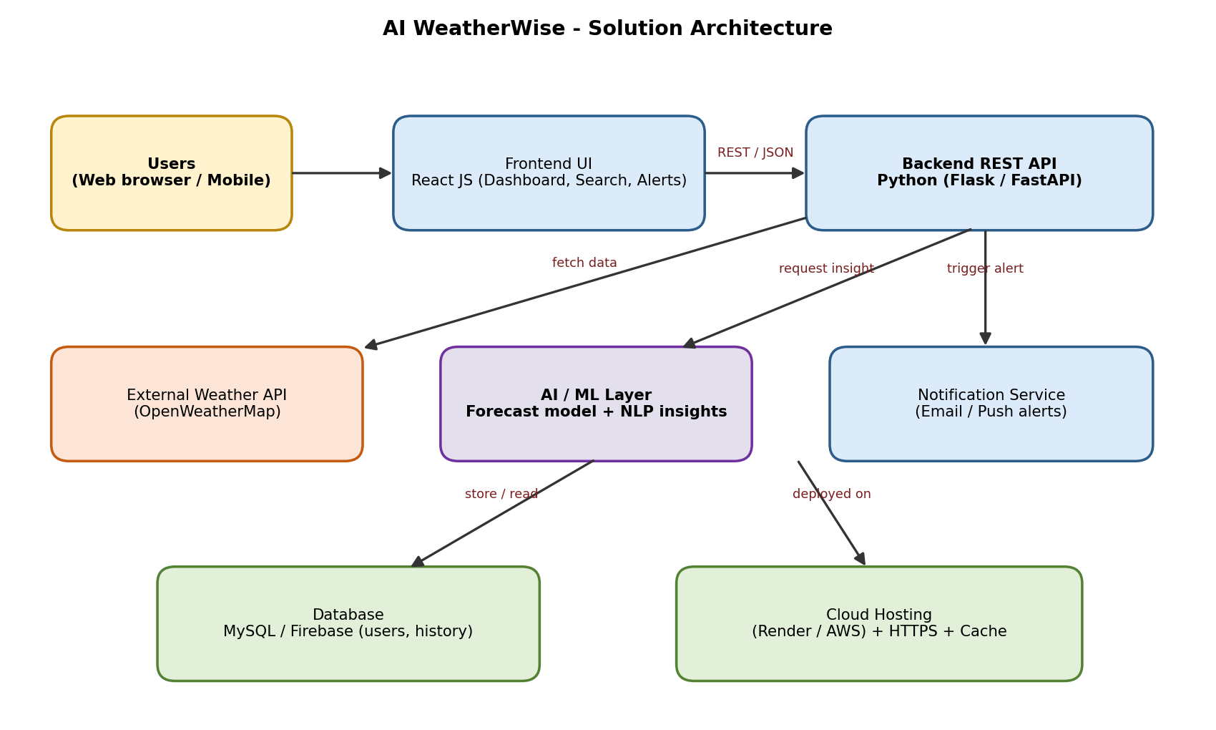
Figure 1: Architecture and data flow of the AI WeatherWise application
Architecture Description:
- User interface: users open the React JS web dashboard on a browser or phone, search a city or allow auto-location, and view live weather, forecast, AQI, AI summary and alerts.
- Backend REST API (Python Flask / FastAPI): handles authentication, validates requests, fetches data and coordinates all other components.
- External Weather API (OpenWeatherMap): supplies current weather, hourly and 7-day forecast, geocoding and air-quality data in JSON format.
- AI / ML layer: a scikit-learn model predicts short-term rain probability from weather history, and a generative-AI component converts weather data into plain-language summaries and personalised tips.
- Notification service: a scheduler checks alert thresholds and sends severe-weather emails and the daily morning briefing.
- Database and cache: user profiles, favourite cities and weather history are stored in MySQL / Firebase; recent API responses are cached to improve speed and reduce API calls.
- Deployment: the application runs on a cloud platform (Render / AWS) over HTTPS with environment-variable based API-key protection.

